"Ship of Hanno"

The purpose of this website is twofold:
1). To blog about my personal journey as an Arab American and "Classicist," a problematic and antiquated term for those who study and teach the ancient languages, history, and culture of the Greeks, Romans, and Ancient Mediterranean. I will try to include providing some book reviews and resources for Latin teachers, which will focus on passages and excerpts of Greek and Latin that relate to the ancient Near East and North Africa.
2). To share my development of two separate book projects: one is an ancient historical fiction novel in English for mass audiences, tentatively titled The Lost Bard of Ithaka; the other is a Latin novella book, which I am composing in Latin with notes and commentary in English for Latin language learners to read about the life and times of Zenobia of Palmyra, Syria, called Zenobia Palmyrena: Inter Duas Orbes.

I am developing a fictional novel, the first in a series, which will introduce modern readers to diverse characters of the ancient Mediterranean, challenging readers to rethink their perspective on events from the Greco-Roman past. While so many previous writers and scholars have emphasized the perspectives of Greek and Roman elites, whenever attention has been drawn to women, slaves, and foreigners who challenged Roman hegemony, it has often been exclusively centered on British and German barbarians for white audiences today. But if you transpose the boundaries of the Roman Empire onto a modern map, Arabic and Turkish speaking peoples would make up the majority of people who would be citizens of the Roman Empire today. While there were conflicts between Near Eastern and Greco-Roman peoples, the relationship between the regions was more complicated than modern media has portrayed it. The Roman Empire was diverse, and that diversity of peoples and traded goods enriched Rome.

I have taught ancient Greek, Latin, Mythology, and Roman History to students of all ages and diverse backgrounds. As a university lecturer, I have taught courses specifically on "Rome & Carthage in the Republic", "Rome & Jerusalem in the 1st centuries", and "Rome & Constantinople in the Late Roman Empire." Each of those classes encouraged students to read about and explore Rome's complex, imperialist relationships with the Eastern Mediterranean and North Africa. The Middle East has been called the cradle of western civilization (a problematic term still used by white supremacists), yet Near Eastern studies was separated from Greek and Roman studies and relegated to the side, as Greece and Rome took center stage, glorified by white supremacists who perpetuated racist ideologies and false assumptions of the past.

The title of my blog, “Ship of Hanno,” is a reference to the Phoenician navigator of the 5th c. BCE, who sailed from Carthage in North Africa to Morocco and South along the coast of West Africa down to Gabon near the equator. Hanno's journey was famously mentioned by numerous Greek and Roman authors, such as Herodotus. We are fortunate to still have a description of that voyage. Like my Phoenician forebears, my intellectual curiosity prefers to sail wine-dark seas, while exploring diverse avenues of inquiry and carrying back home precious keepsakes from my intellectual meanderings. Depth of analysis without breadth in perspective leads you to myopic conclusions.

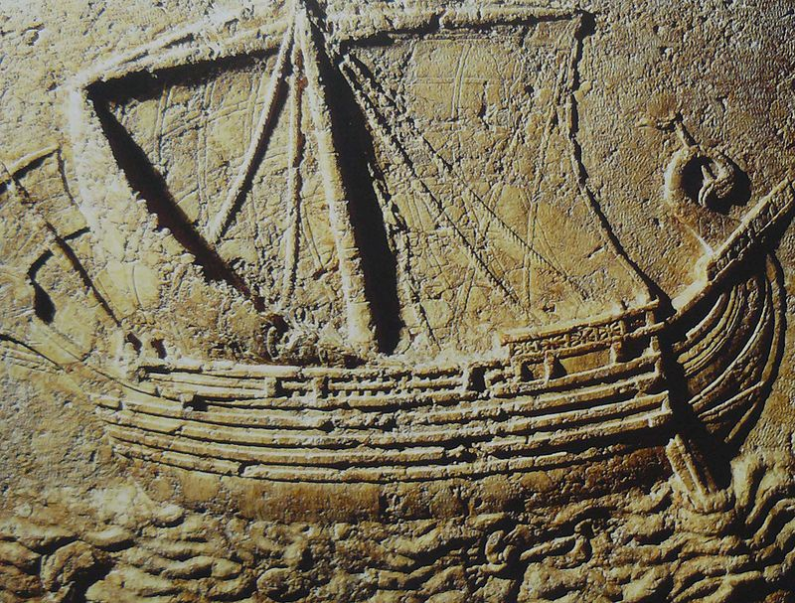
Figure 1: Wiki image by Elie

I was originally going to start this website a decade ago, while I was finishing my master’s degree. But when I mentioned it to a couple of faculty and staff in my department, they heavily discouraged me from moving forward with it. One even smirked at the idea that anyone would be interested in what a grad student might have to say about their academic journey. What’s worse is that they were framing it in a way that they were simply protecting me and my future career, suggesting that a silent grad student is what professors want to see, an empty vessel for them to fill. Of course, despite crisscrossing the country and parts of Europe for my education and potential career, my quiet diligence has proffered me nothing but massive debts and precarious, underpaid, and undervalued work.

There are some college professors who have supported and assisted even undergraduate college students to get some minor publishing credit on a paper, article, or group project overseen by the professor. Even high school students at elite preparatory schools have been taking initiatives which look great on college applications, opportunities which most young students from working class, historically marginalized communities typically do not get. And in a "publish or perish" environment, encouraging young students to publish, while working on a research project with a professor, is a beneficial way to prepare academic students in Humanities for a doctoral program. So, I find it oddly frustrating that none of my Humanities professors gave me such an opportunity, despite awarding me and recommending me for graduate programs where I arrived unprepared.

